Verification of Kirchhoff’s Laws Through Simulation

Name of Student: _______________________________________________________________
Course and Section: ______________ Date Performed: ___________

Circuit Simulation using Multisim
Instruction:
Construct the circuit shown in Figure 1 using Multisim. Use the following electrical components in your design:
- Two DC voltage sources (ensure that the direction of polarity is correct)
- Three resistors (as specified in the figure)
- Multimeters configured to measure current
After building the circuit, use multimeters to view the current flowing through each resistor. Record all measured values systematically in Table 1 for analysis.

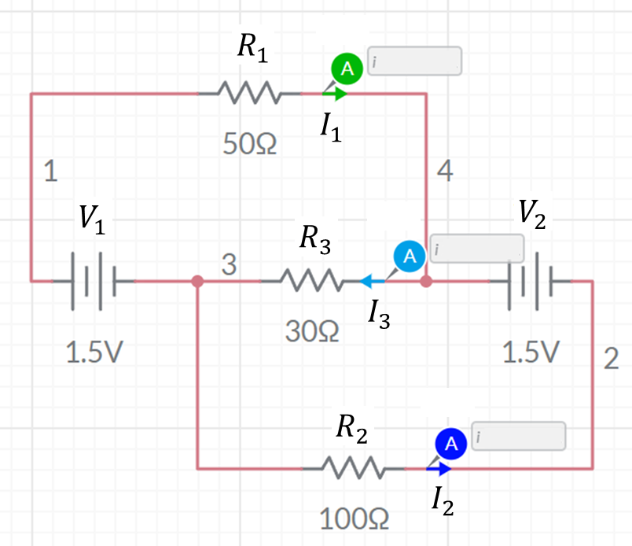
Figure 1. Multisim Simulation of a DC Resistive Circuit with Multiple Sources

Table 1

Resistors | Current
R₁ = 50 Ω | I₁=
R₂ = 100 Ω | I₂=
R₃ = 30 Ω | I₃=

Computational Calculation with the aid of MATLAB
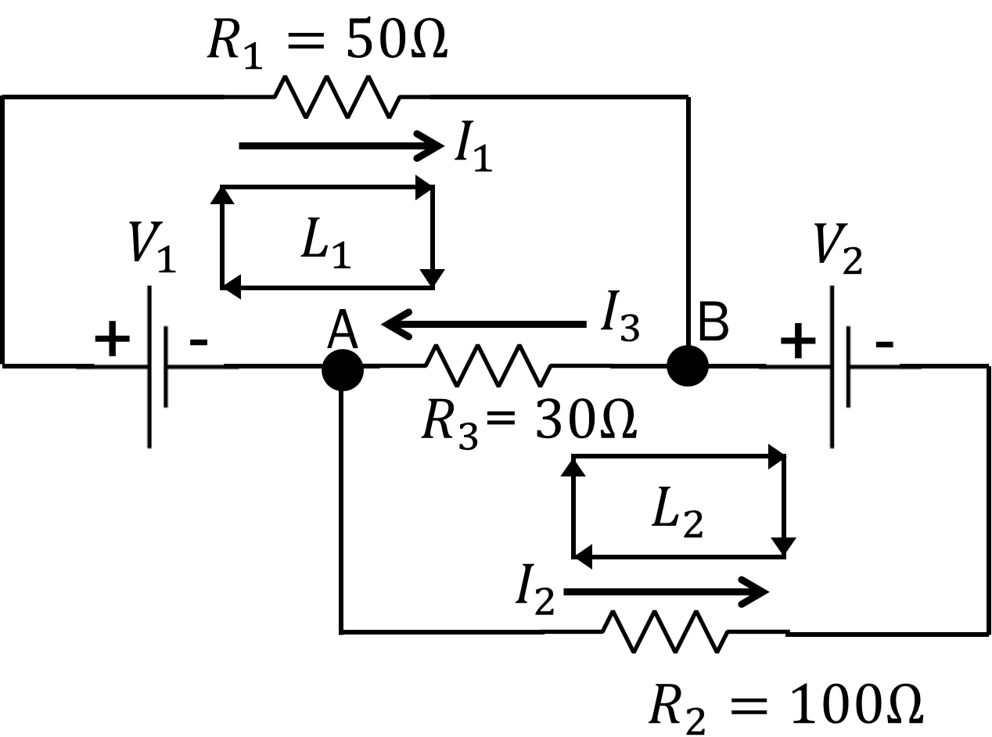
Figure 2. Annotated Schematic DC Circuit Used for Kirchhoff’s Loop Analysis

  - Write the equations at each node and each loop using Kirchhoff’s Laws (refer to Figure 2)

Node A (KCL):

Node B (KCL):

Loop 1 (KVL):

Loop 2 (KVL):

  - Write the three important equations in solving the current along the three main paths.

Eq. 1

Eq. 2

Eq. 3

  - Using the three equations, solve the value of each current using MATLAB. Record the final answers below.

$$I_{1}=$$
$$I_{2}=$$
$$I_{3}=$$

